how to digitize analog design in design space
If by “digitize analog design in design space” you mean converting an analog circuit design problem into a digital/design-space exploration (DSE) workflow, the idea is to represent the analog circuit using parameters, constraints, objectives, and performance metrics, and then search the design space automatically.
1. Define the analog design space
For example, for a CMOS common-source amplifier:
Category | Design variable
Transistor
Load
Bias | ,
Supply
Compensation
Device type | NMOS/PMOS
Instead of manually selecting values, define ranges:
This collection is your design space.

2. Convert circuit performance into measurable objectives
The simulator evaluates each candidate circuit and produces:
- DC operating point
- Voltage gain
- Bandwidth
- GBW
- Phase margin
- Power consumption
- Noise
- Output swing
- Area
- Linearity
- PSRR/CMRR
For example:
and
You can then define a multi-objective problem such as:
subject to:

3. Create a parameterized circuit
Instead of a fixed transistor:
M1 drain gate source bulk NMOS
use parameters:
M1: W = Wn
L = Ln
and define:
Wn = design variable
Ln = design variable
RD = design variable
IBIAS = design variable
The same circuit can then be simulated hundreds or thousands of times with different parameter combinations.

4. Automate simulation
The basic flow becomes:
Design Variables
↓
Circuit Netlist
↓
SPICE/EDA Simulator
↓
Performance Extraction
↓
Objective/Constraint Evaluation
↓
Optimization Algorithm
↓
New Design Point
↓
SPICE Simulation
↺
For your Siemens EDA environment, this can be implemented around the schematic/netlist and SPICE simulation flow using the appropriate simulator such as Eldo.

5. Use Design Space Exploration (DSE)
You can explore the space using:
Simple methods
- Grid search
- Random search
- Monte Carlo
Optimization methods
- Gradient-based optimization
- Genetic Algorithm
- Particle Swarm Optimization
- Simulated Annealing
AI/ML-based methods
- Bayesian Optimization
- Neural-network surrogate models
- Gaussian Process models
- Reinforcement Learning
- Evolutionary optimization
A useful modern architecture is:

6. “Digitizing” the analog design
A powerful way to think about this is:
Traditional analog design
Designer → equations → transistor sizing → simulation → redesign
Digitized analog design
Parameters → automated simulation → numerical data → ML/optimization → optimum circuit
For example, generate 5,000 designs:
W | L |  | Gain | GBW | Power | Area
2 µm | 250 nm | 20 µA | 18 | 120 MHz | 0.25 mW | 10
5 µm | 250 nm | 30 µA | 25 | 180 MHz | 0.38 mW | 18
10 µm | 500 nm | 50 µA | 32 | 210 MHz | 0.65 mW | 35
... | ... | ... | ... | ... | ... | ...
This becomes a digital representation of the analog design space.

7. Pareto-optimal designs
For analog circuits, there usually isn't one universally best design.
For example:
So instead of finding one optimum, find the Pareto front.
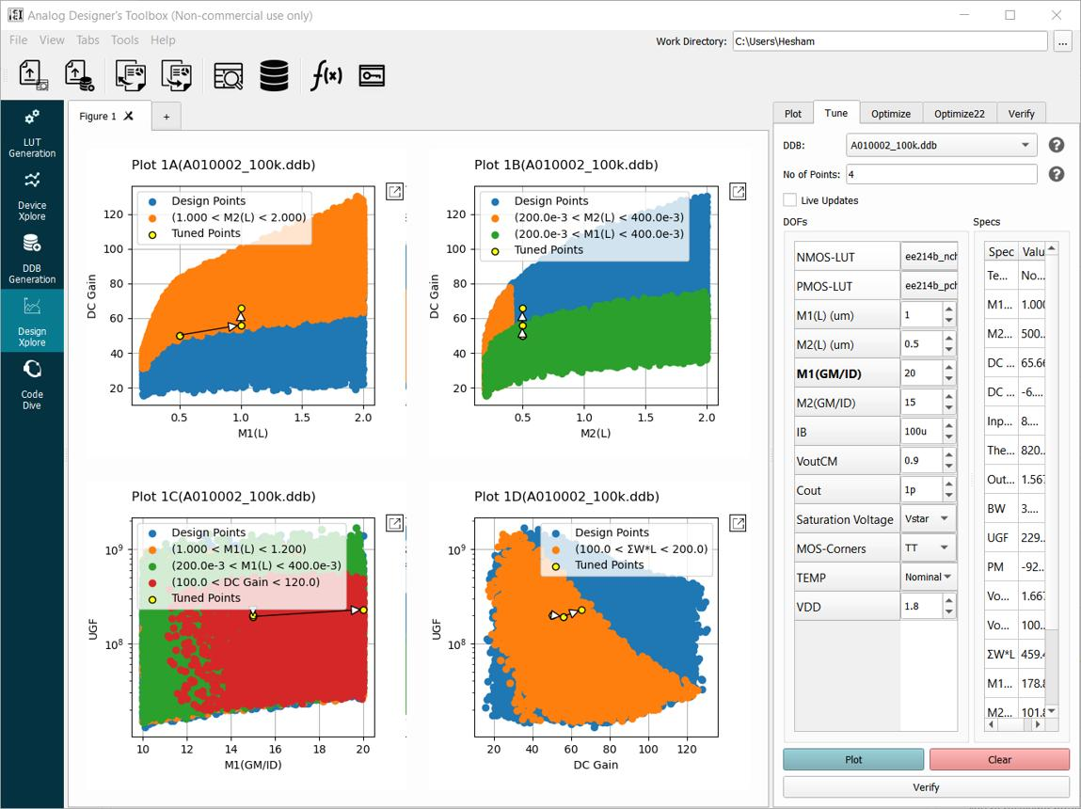
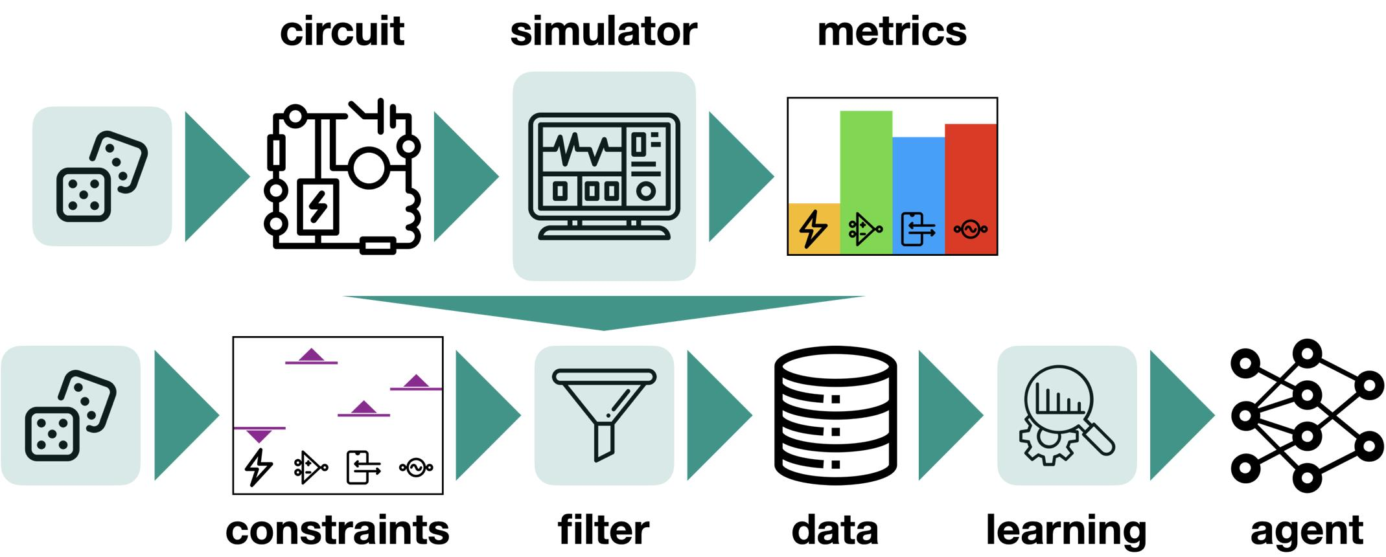
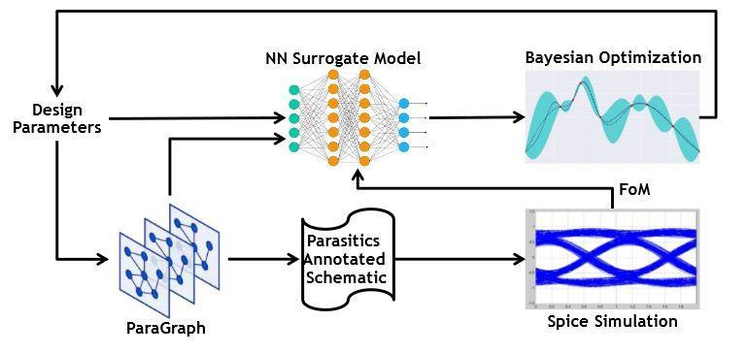
6
A point is Pareto-optimal if you cannot improve one objective without degrading another.
For example:
Gain
↑
● ●
● ●
●
●
●
────────────────────→ Power
The upper-left boundary represents attractive designs.

8. Recommended framework for your VLSI research
Since you are working with analog CMOS/FinFET amplifier design, a particularly useful research architecture would be:
ANALOG CIRCUIT
│
▼
Parameterized Netlist
│
▼
Siemens Eldo
│
┌────────┴────────┐
▼ ▼
DC/AC Analysis Transient
│ │
└────────┬────────┘
▼
Performance Dataset
│
▼
ML Surrogate Model
│
▼
Design Space Exploration
│
┌───────────┼───────────┐
▼ ▼ ▼
Gain/GBW Power Area
│ │ │
└───────────┼───────────┘
▼
Pareto Optimization
│
▼
Optimal Designs
│
▼
Final SPICE Validation
Example research problem
You could formulate:
“AI-Assisted Design Space Exploration and Optimization of CMOS/FinFET Analog Amplifiers.”
Design variables:
Performance vector:
Then learn:
using simulation-generated data.
Once the surrogate model learns , optimization can search millions of possible combinations much faster than running SPICE for every point.
In short: digitizing analog design means turning the analog designer's experience and circuit equations into a parameterized, simulation-driven, data/AI-based design-space exploration system. This is particularly suitable for your 250-nm CMOS, 180-nm CMOS, FinFET, and 6G analog amplifier designs.
Give all mathematical relations between design variables "
Transistor | Wn​,Ln​

Load | RD​

Bias | IBIAS​, VBIAS​

Supply | VDD​

Compensation | CL​

Device type | NMOS and measurable objectives
"DC operating point
- Voltage gain Av​
- Bandwidth
- GBW
- Phase margin
- Power consumption
- Noise
- Output swing
- Area
- Linearity
- PSRR/CMRR".
Yes. For a common-source CMOS amplifier with resistive load , the design variables
can be mathematically related to the measurable objectives
Below is a comprehensive set of relations that can be used to digitize the analog design space and construct an optimization/design-space-exploration model.

1. MOSFET DC operating-point relations
For an NMOS in saturation:
where
Therefore,
for the first-order model.
The transconductance is
or
and equivalently,
Thus:

2. Relation between
If
then
Therefore,
and
This is one of the most important relationships for DSE.
It means that , , , and are not independent.

3. Drain voltage
For a resistive-load common-source amplifier,
Therefore,
This directly relates:
The transistor must remain in saturation:
Thus,
This becomes an important design constraint.

4. Maximum allowable
From the saturation condition:
Therefore,
Since
we obtain

5. Voltage gain
For a common-source amplifier:
where
Therefore,
If ,
Using
gives
Hence:

6. Gain in terms of
Since
we get
Therefore,
This is particularly useful for optimization.

7. Output resistance
The MOSFET output resistance is
and approximately
Therefore,
Increasing generally increases , which can increase gain.

8. Channel-length modulation
A simple relation is
Therefore,
and
This explicitly introduces into the gain equation.

9. Load capacitance and bandwidth
The dominant output pole is approximately
where
Thus,
If ,
Therefore:

10. Gain-bandwidth product
For a single-pole amplifier,
Using
and
we get
Therefore,
Hence:

11. Phase margin
For a simple dominant-pole system:
with
The phase is
For a single-pole amplifier, the phase margin is approximately
in the ideal single-pole case.
With additional parasitic poles:
where

12. MOS parasitic capacitances
The important capacitances are
Approximately,
and
to first order, depending on the operating region and technology.
Total output capacitance can be represented as
Therefore,
This is more realistic than using alone.

13. Miller effect
For a common-source amplifier,
Therefore,
and
Thus, increasing gain can increase input capacitance and reduce bandwidth.

14. Power consumption
The DC power is
For the simple CS amplifier:
Therefore,
Thus:

15. Dynamic power
For capacitive loading,
where is the switching/activity factor.
For analog circuits, this is less dominant than in digital circuits, but it becomes important for high-frequency operation.

16. Power-delay relationship
Since
and
a useful figure of merit is
Therefore,
Using
gives
for the simplified model.

17. Thermal noise
MOSFET channel thermal noise current density is approximately
where is the channel thermal-noise coefficient.
Input-referred voltage noise is
Therefore,
and
Thus increasing or generally reduces input-referred thermal noise.

18. Flicker noise
A simplified noise model is
Therefore,
Increasing transistor area
reduces flicker noise.

19. Total input-referred noise
A simplified model is
This gives an important design-space relationship:

20. Output swing
The maximum output voltage is constrained by transistor saturation.
For NMOS:
Therefore,
and
Hence:
or approximately,
For a symmetric output swing around the Q-point, the actual swing is limited by both the upper and lower distances from the quiescent drain voltage.

21. Quiescent output voltage
The positive output swing is approximately
The negative output swing is approximately
Thus,

22. Maximum symmetrical output swing
For approximately symmetric swing:
Therefore,
Since
we obtain
This is a very useful design equation.

23. Transistor area
The active transistor area is approximately
Therefore,
For the complete amplifier:

24. Relation between area and flicker noise
Since
and
we obtain:
This creates a fundamental trade-off:

25. Linearity
For a nonlinear amplifier:
The voltage gain around the operating point is
Second-order distortion:
Third-order distortion:
Thus,

26. IIP3
For a simplified third-order model:
The exact expression depends on the definition and normalization of the polynomial coefficients.
Higher IIP3 means better linearity.

27. PSRR
Power-supply rejection ratio is
Alternatively, using transfer functions:
Higher PSRR is better.
Supply coupling can be represented as
Therefore,

28. CMRR
For a differential amplifier:
and
Therefore,
in dB:
For a simple differential pair, is strongly affected by tail-current-source output resistance and transistor matching.

29. Bias voltage relationship
For the simple square-law model:
Solving for :
This is particularly useful when are selected by an optimization algorithm.

30. from target gain
Assuming
then
Since
we obtain:
This allows you to directly calculate the required for a target gain.

31. from target gain
Therefore,
Using
gives

32. from target gain
Rearranging:
gives

33. from target bandwidth
From
we obtain:
If :

34. from target GBW
Since
we obtain:
and

35. Unified mathematical design-space model
Your entire analog design problem can therefore be represented as:
and
where
A simplified dependency matrix is:
Objective | Main design variables
GBW
PM | , poles
Power
Thermal noise
noise
Output swing
Area
Linearity
PSRR | , bias network
CMRR | , matching, tail source

36. Most important trade-offs for Design Space Exploration
The equations reveal several important trade-offs:
Gain vs Power
while
Therefore increasing can increase gain but also increases power.
Gain vs Bandwidth
while
Therefore increasing increases gain but decreases bandwidth.
GBW vs Power
and
while
Hence:
approximately, for fixed and .
Noise vs Power
and
so approximately:
Increasing current improves noise, but with diminishing returns.
Area vs Flicker Noise
and
therefore:

Final DSE formulation
For an automated analog design-space exploration system, you can formulate the problem as:
subject to:
with the fundamental transistor constraint
and
This mathematical formulation is the basis for building a digital twin/design-space model of an analog amplifier, where each point corresponds to one circuit candidate and the simulator provides the objective vector.
